11/14/2024 – Day-1 of Linux training.

Index:

* Introduction to Linux Operation System
* History of Linux and Various Distributions
* Interacting with Linux Shell
* The Linux Directory Structure
* Files and Permissions
* Essential Linux Commands – File & Directory Manipulation
* Input, Output, Redirection and Pipes
* Searching Files – Find, SED, AWK
* Environment Variables
* Processes and Job Control with Cron
* Switching users and Running Commands as others
* Software installation commands – RPM Based and Debian based

GNU – GNU stands for GNU’s not Unix, it’s a program like Unix with different internal program. The GNU in GNU is pronounced goo nuu.

Kernel - Device access, file system, multi tasking.

Multi tasking - doing multiple tasks at the same time but there is very little time gap(ns).

Multi threading - In a task multiple threads are used to do task.

Shell - bash, sh, tcsh.

Utilities - wc, cat, sort, gcc, emax, grep, awk.

Linux O/S core was developed by Linus Torvalds.

GNU utilities were written by Richard stallman and team.

Connection transfer and protocols - ssh(Secure shell), x-win(X - windowing), sftp(secure file transfer protocols).

Linux command basics:

[username@scc1 ~]$ command --option argument

Command: Command/program that does one thing

Options: Change the way a command does that one thing

* Short form: Single-dash and one letter e.g. ls -a
* Long form: Double-dash and a word e.g. ls --all

Argument: Provides the input/output that the command interacts with.

**Commands practice:**

**Whoami**

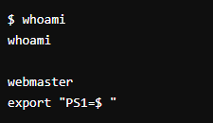

**Hostname**

**echo "hello, world"**

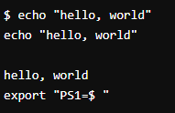

**Echo $HOME**

**echo my login is $(whoami)**

**Date**

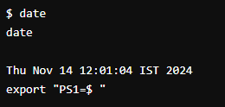

**Cal ---------- Not working**

**Shazam ---------------------- Not working**

**Commands: Selected text processing utilities**

* **awk : Pattern scanning and processing language**
* **Example: awk ‘{print $1}’ file.txt**

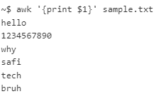

* **cat : Display file(s)**
* **Example: cat sample.txt**



**The output is shown after next few pages**

* **cut : Extract selected fields of each line of a file**
* **Example:**

* **diff : Compare two files**
* **Example:**

* **grep : Search text for a pattern**
* **Example:**

* **head : Display the first part of files**
* **Example: **

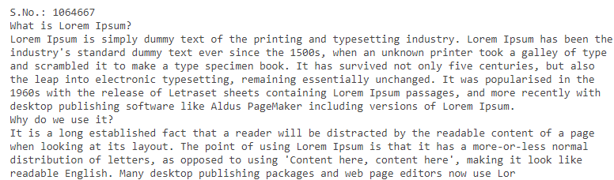

* **less : Display files on a page-by-page basis**
* **Example: **

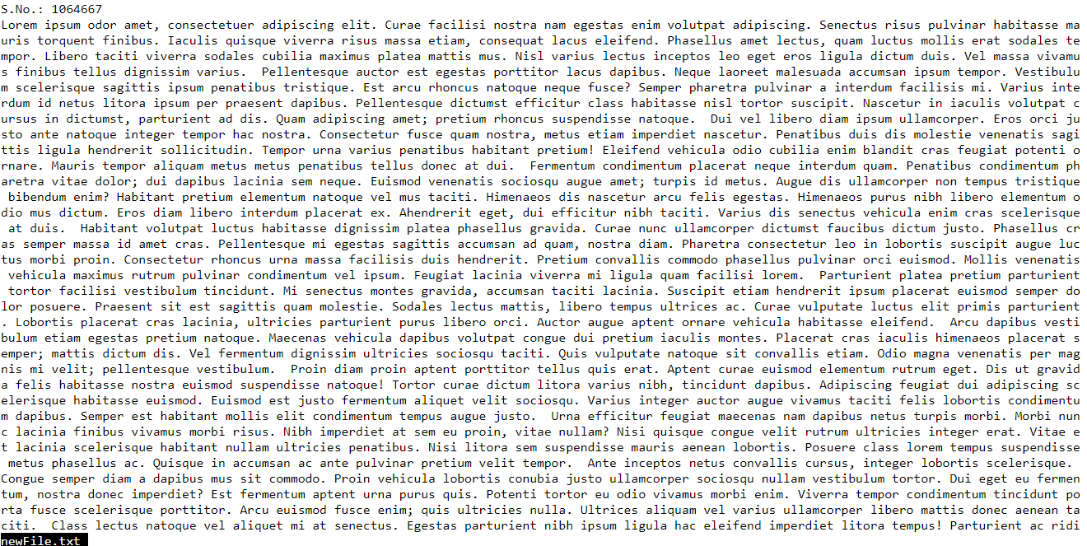

* **sed : Stream editor (esp. search and replace)**
* **Example: The -> boo**



* **sort : Sort text files**
* **Example:**

* **split : Split files**
* **Example:**

* **tail : Display the last part of a file**
* **Example:**

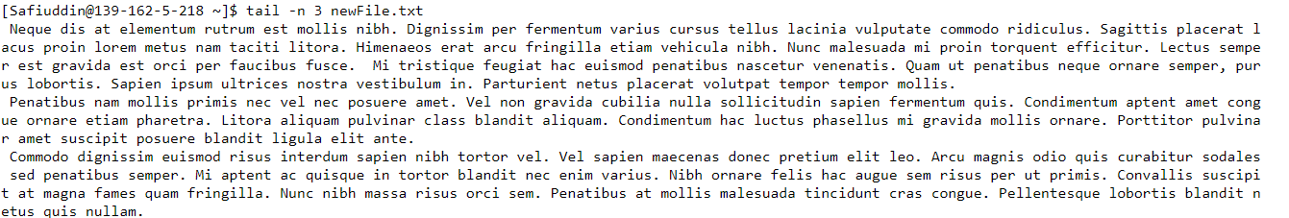

* **tr : Translate/delete characters**
* **Example:**

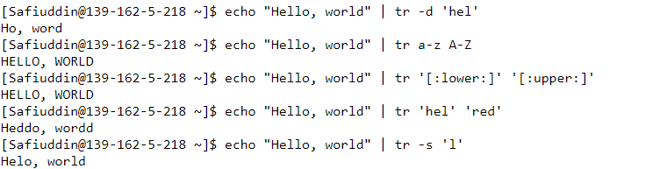

* **uniq : Filter out repeated lines in a file**
* **Example:**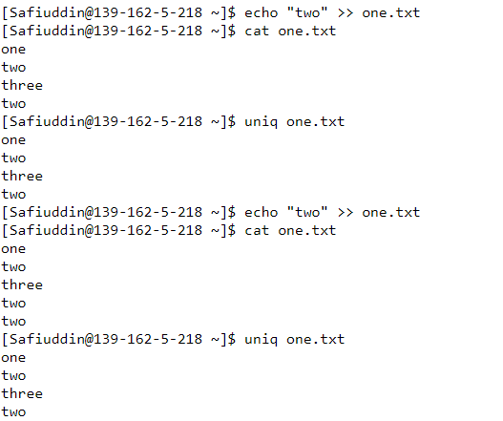
* **wc : Line, word and character count**
* **Example:**

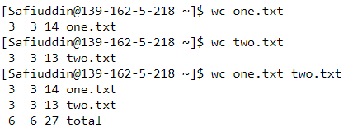

**Creating a file:**



**Putting content to the file:**

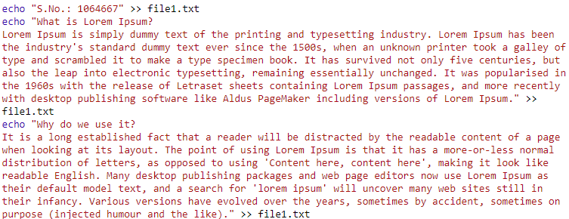

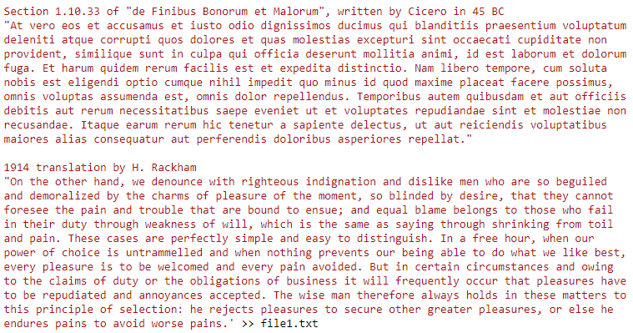

**Displaying content of the file**



**Renaming the file**

